6773, 6774, 90771, 90772, 90773 & 90774 Adventure Door
Installation Instructions

Contents: | Qty | Contents: | Qty
Driver Door | 1 | #10 size Black Machine Screws | 8
Passenger Door | 1 | #10 size Nylock Nuts | 8
Paddle Handles | 2 | #8 Oval Head Screw (90771/90772 ONLY) | 2
5/16” Flatwasher (90773/90774/6773/6774 ONLY) | 4 | #8 Flatwasher (90771/90772 ONLY) | 2
5/16” Nyloc Nut (90773/90774/6773/6774 ONLY) | 4 | 3/8” Lock Nut (90771/90772 ONLY) | 2
 |  | Rubber Snubber (90771/90772 ONLY) | 2

Important: Before starting your installation, determine which door is the driver side and which door is passenger side. You can identify this by the stenciled ‘WP’ logo plate that should correctly read from the outside of the vehicle. “W’ on the left, ‘P’ on the right. Additionally, the JKs paddle handle mounting plate is welded to the interior side of the tubes, so when you look at the door from the outside of the vehicle the tubing of the door is positioned in front of the paddle handle mounting plate. These images show the orientation of the WP plate and the JKs paddle handle mounting plate.
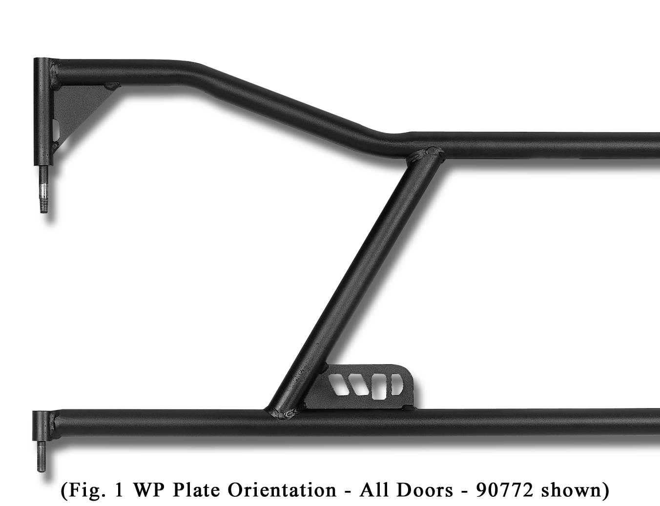
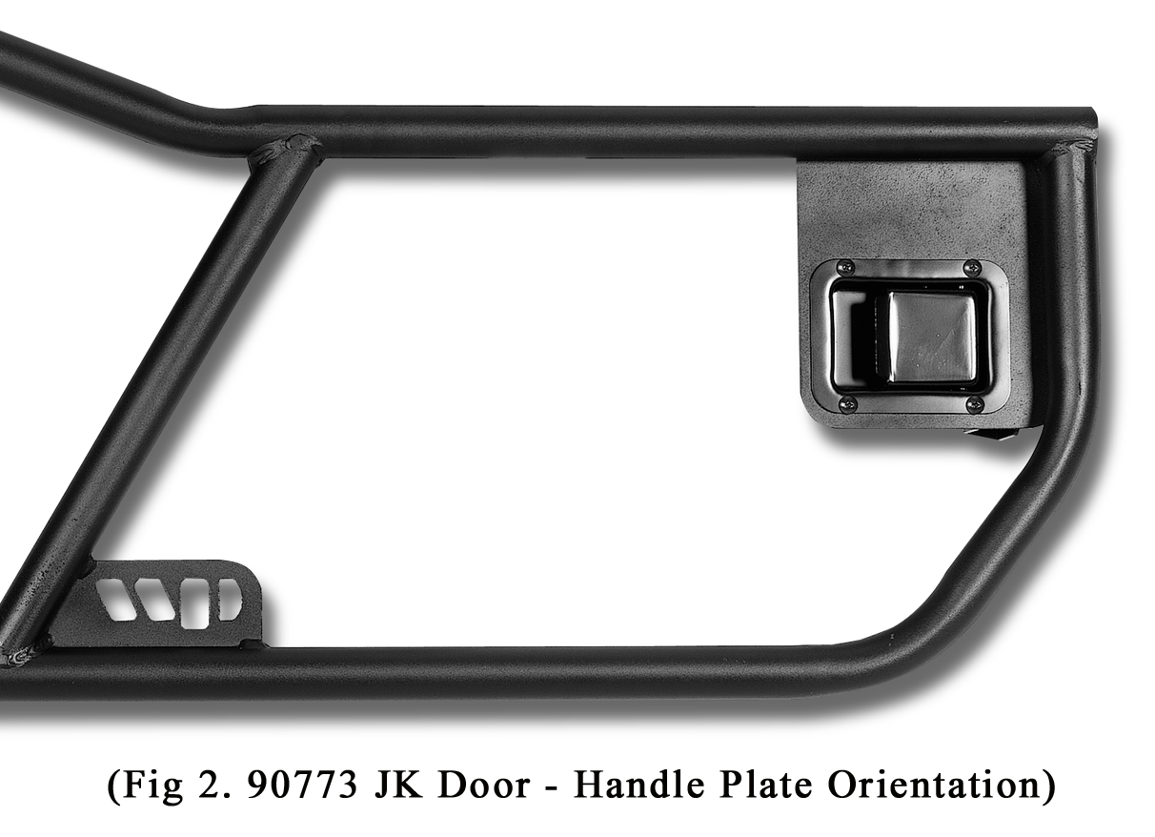

PHASE 1: Factory Door Removal
- Start by removing your door security bolts located at the bottom of the door hinges. On older TJ models these are a simple hex nut, but on the newer JK Jeeps, they are a TORX head nut. We recommend that you roll down your windows to not only protect the glass while the doors are stored, but to give you an extra holding place while carrying the removed door.
- Unhook the doors’ limiting strap from the anchor located in the kick panel area just in front of the door. On the rear doors of the JK Unlimited model, the anchor is located behind a small access panel. Pry this panel outward to release the spring clips that hold it into place, then reach in and unhook the liming strap.
- JK Jeeps also require unplugging the wiring for the power windows and locks. On the front doors, you may locate the plug by following the limiting strap webbing up into the kick panel recess. The plug has a red sliding locking tab that needs to be unlocked to access the release button. Push the release button on the plug and disconnect downward. For the 4 door Unlimited, there is a plug much like the ones in the front, but these will be located behind the small access panel you removed earlier to unhook the limiting strap. Reach inside, slide the locking tab, push the button and disconnect the plug downwards.
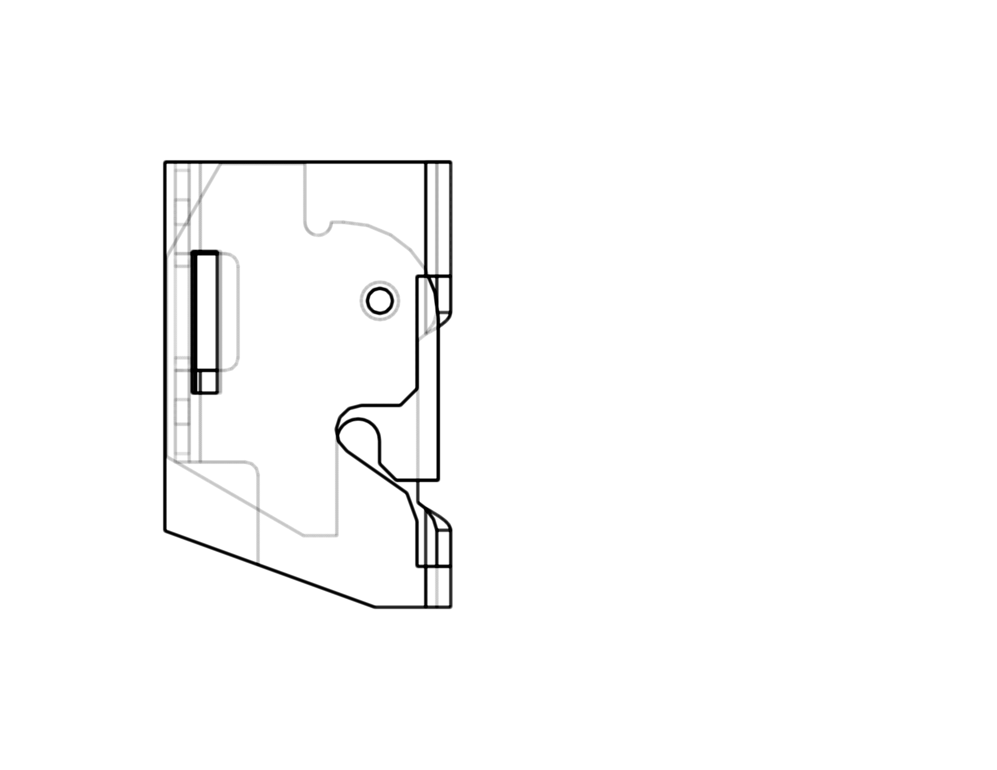
- Tuck the plugs into the door pockets and remove the doors by lifting up off the hinges.
CLOSED
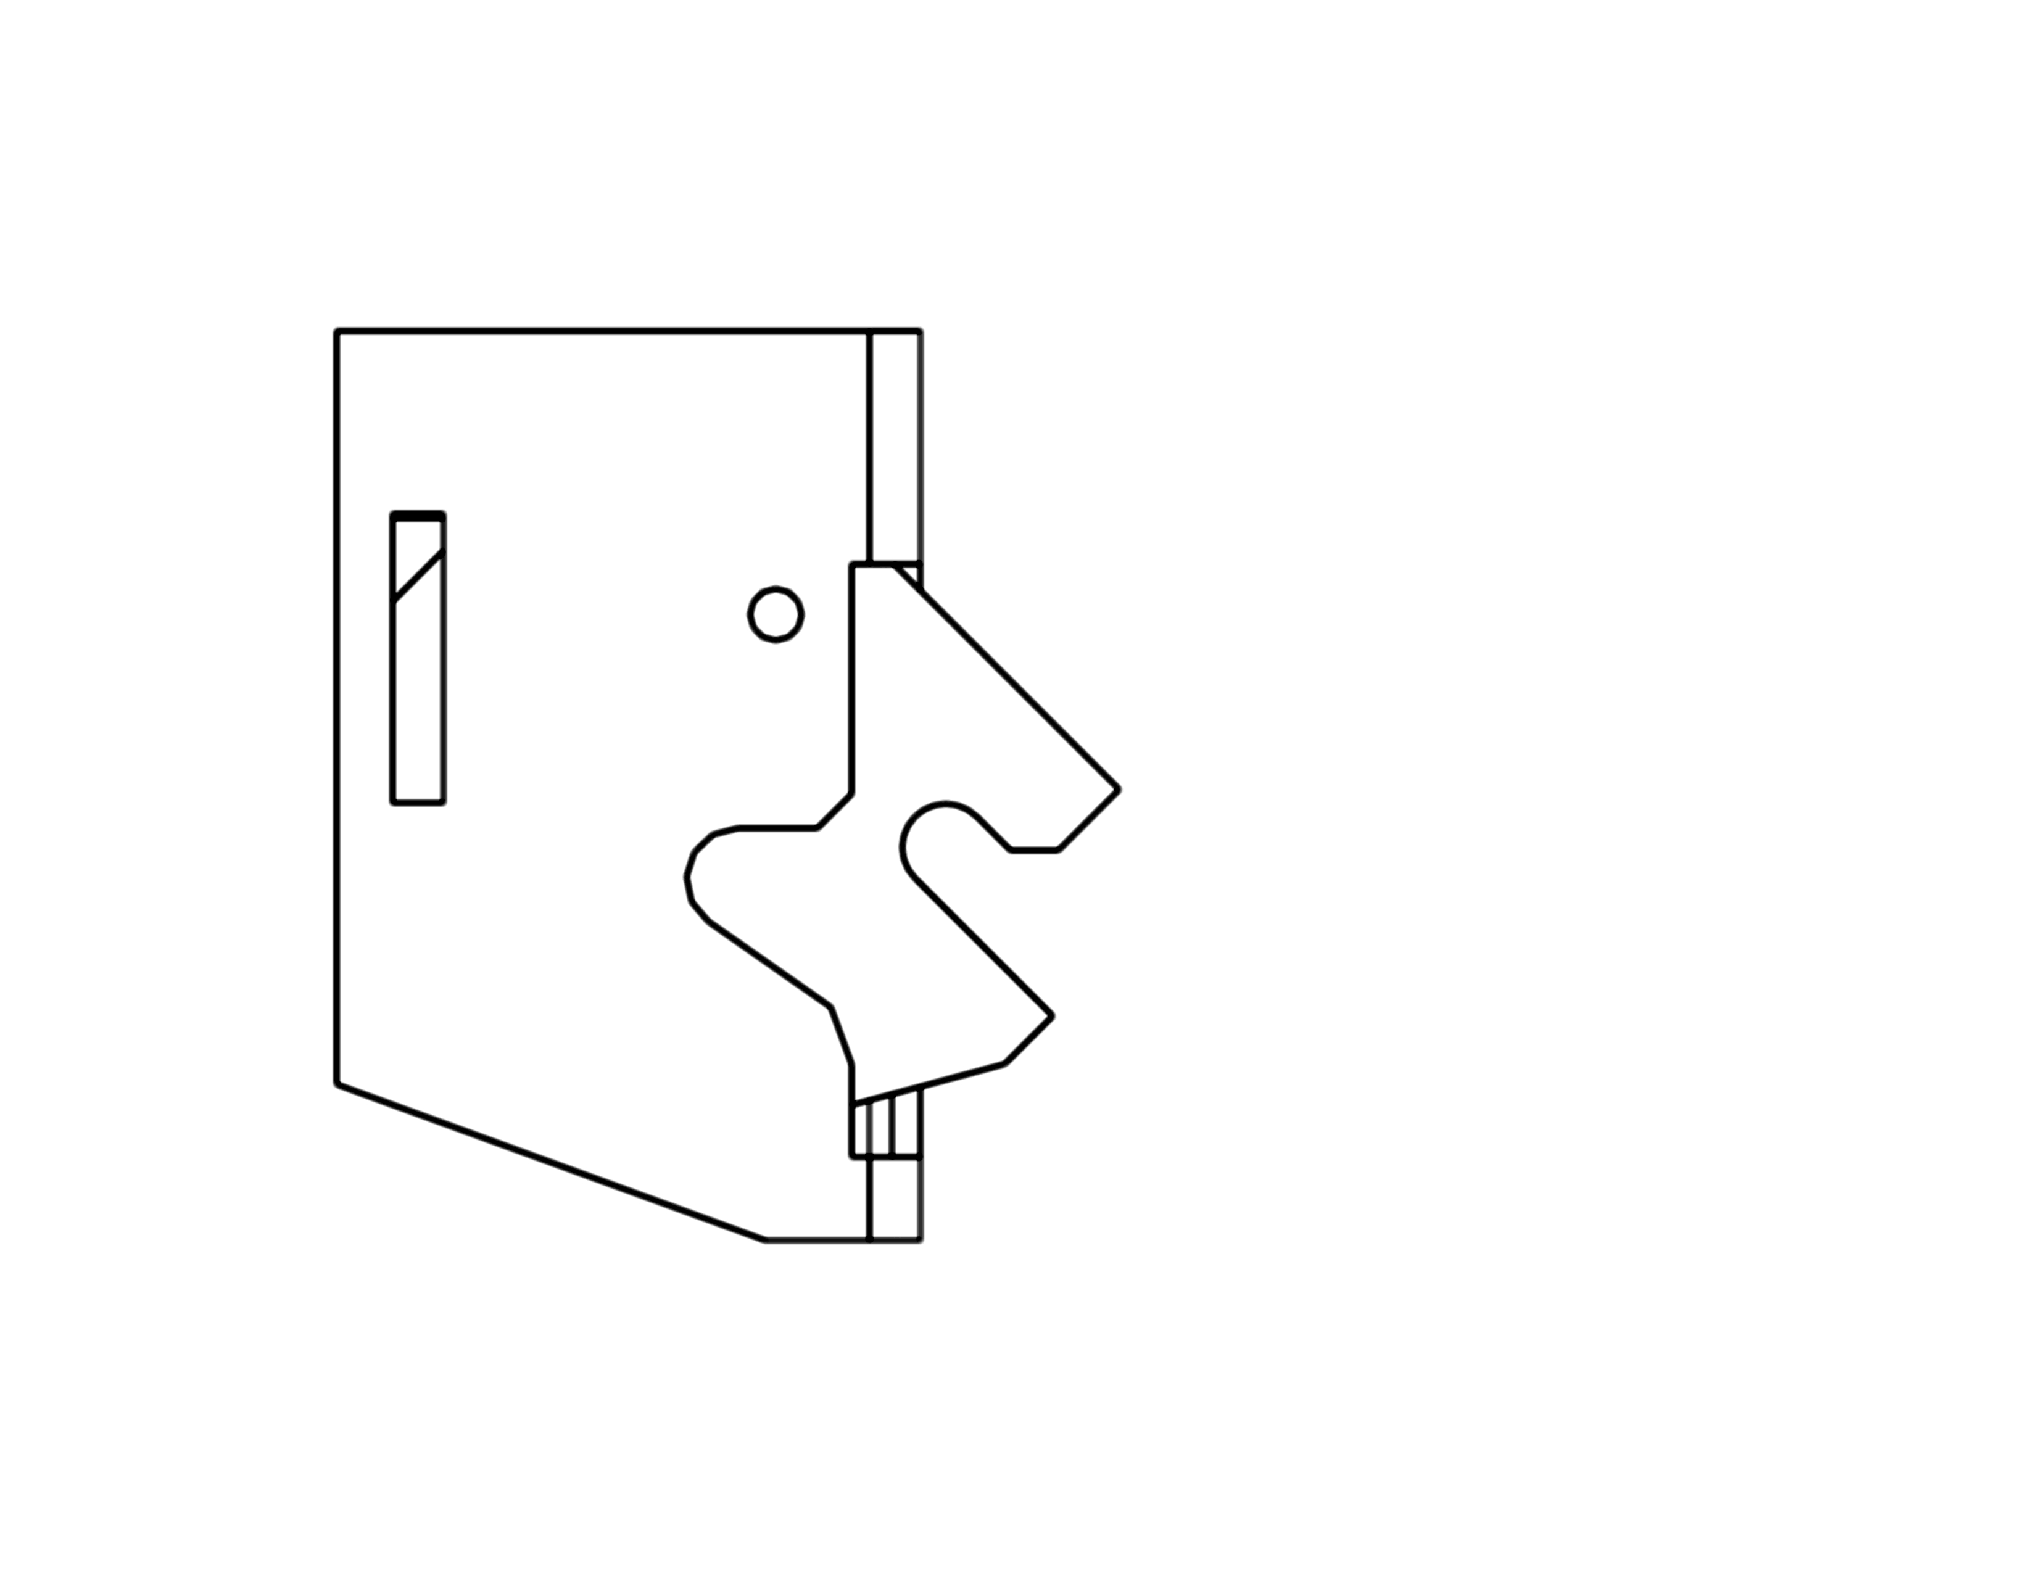
OPEN
PHASE 2: Door Assembly
- Identify your left and right side tube doors as directed above.
- Next, install your paddle handle into the door. The paddle handles will install from the outside of the door, inserting them through the paddle mount opening. Please note: The paddle handles will not fit through the opening unless the striker catch is closed. If the striker catch is open, simply push the catch with your finger to rotate it until it latches into the closed position. To ensure you place the paddle handles on the correct side, orient the paddle handle so that the latch mechanism is toward the back of the vehicle, and the open slot of the striker catch faces downward as per the image.
OPEN SLOT FACING DOWN

PHASE 2: Door Assembly (continued)

- Attach the Paddle Handles to the door using the supplied #10 sized black screws and nuts.
- Set the door hinge pins into the hinges on the Jeep. Sometimes, due to powder coat thickness, this may take a little bump from a rubber mallet or simply a couple of taps with your fist to seat them all the way down. A little lithium grease applied to the door pins can also be beneficial.
- DO NOT SLAM THE DOOR SHUT JUST YET! Check the latch mechanism to be certain it’s not in the closed position. Activate the paddle handle on the door and test the opening and closing of the door, checking for alignment with the striker as you do so. You may choose to “fine tune” the alignment of the latch and striker if you like. The door position can be raised by placing small SAE washers over the door pins between the thick door pin shoulder and the Jeep hinge. As the door position is raised, the striker / ramp contact point is lowered. By lowering the contact point of the striker and ramp, the latched interface becomes tighter and reduces chatter. You may also choose to adjust the striker on the door jamb as needed to get proper alignment as well. Mark your striker plates’ original position before making any adjustments so that you can return them to their original spot when needed.
The lower the striker contacts ramp, the tighter the latch interface becomes.
- Install Flatwasher and Nyloc nut on each threaded hinge post, tighten to snug, then back off slightly if door will not easily open and close (optional). NOTE: USE CAUTION WHEN TIGHTENING THE HINGE POST HARDWARE TO DAMAGE THE PAINT WITH THE WRENCH OR SOCKET.
- Once the door is aligned and opening and closing smoothly, you’ve completed the installation for that door. Repeat the steps for the remaining doors.
- Included in the 90771 & 90772 kits are two rubber snubbers that will assist in eliminating door rattle if necessary. Locate a suitable location for the snubber to attach to the tube door and mark for drilling with a ¹/₈” drill bit. Use the #8 oval head screws and #8 flatwashers to secure the snubber to the door. Only tighten until the screw head contacts the shoulder inside the snubber, then just snug down slightly more so you don’t risk pinching through the snubber.

Adventure Door Accessories – Warrior also offers a door limiting strap kit for your Warrior Adventure Doors. This simple and inexpensive strap kit will prevent your doors from opening too far and hitting your Jeep or damaging the paint. Part #90797 fits Warrior Adventure Doors for 87-96 Wrangler (#90771 & #90772). Part #90798 fits Warrior Adventure Doors for ‘07+ Wranglers (#90773). If you experience some rattle with your Warrior Adventure Doors for ‘07+ Wranglers, Warrior now offers part #90764 JK Paddle Handle Snubber Kit that provides an additional rubber contact point and will alleviate this issue.

